**Banking-Portal-Online**

# This project is made by Yash Prajapati (github/@yashpra1010)

**List of Files:**

* **account.jsp**
* **dashboard.jsp**
* **deposit.jsp**
* **depotrans.jsp**
* **Error.jsp**
* **header.html**
* **index.jsp**
* **insert_bankregis.jsp**
* **insert_register.jsp**
* **logout.jsp**
* **register.jsp**
* **validate.jsp**
* **validate2.jsp**
* **withdraw.jsp**
* **withtrans.jsp**

***OUTPUT***

* Page will start from Login Module. If user doesn’t exists in database, it will redirect to “Sign-Up” module.

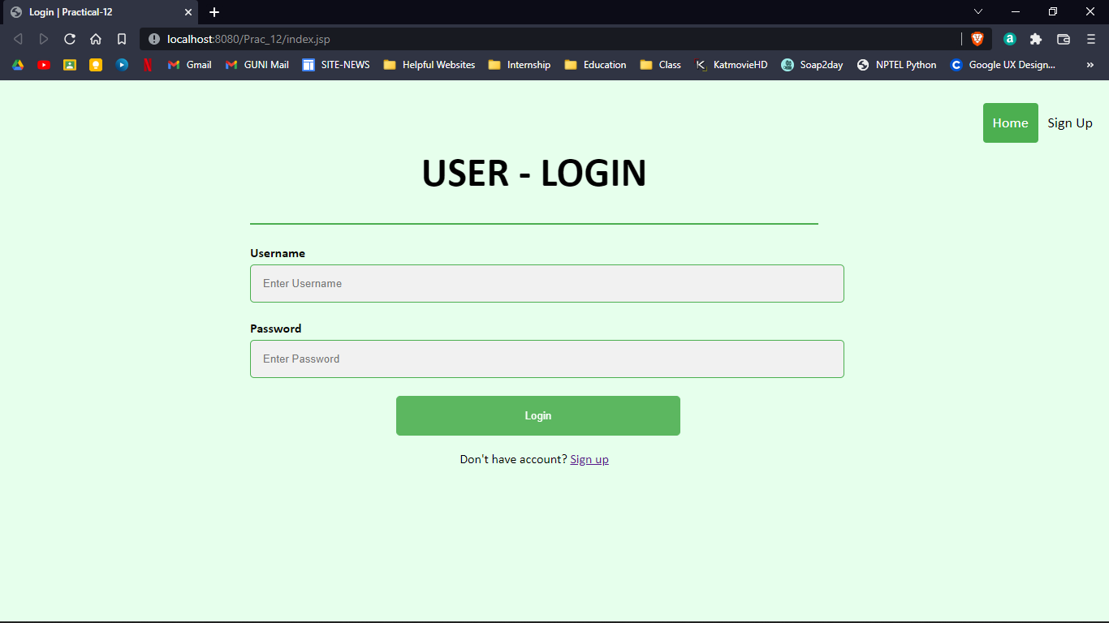

* User Register Page

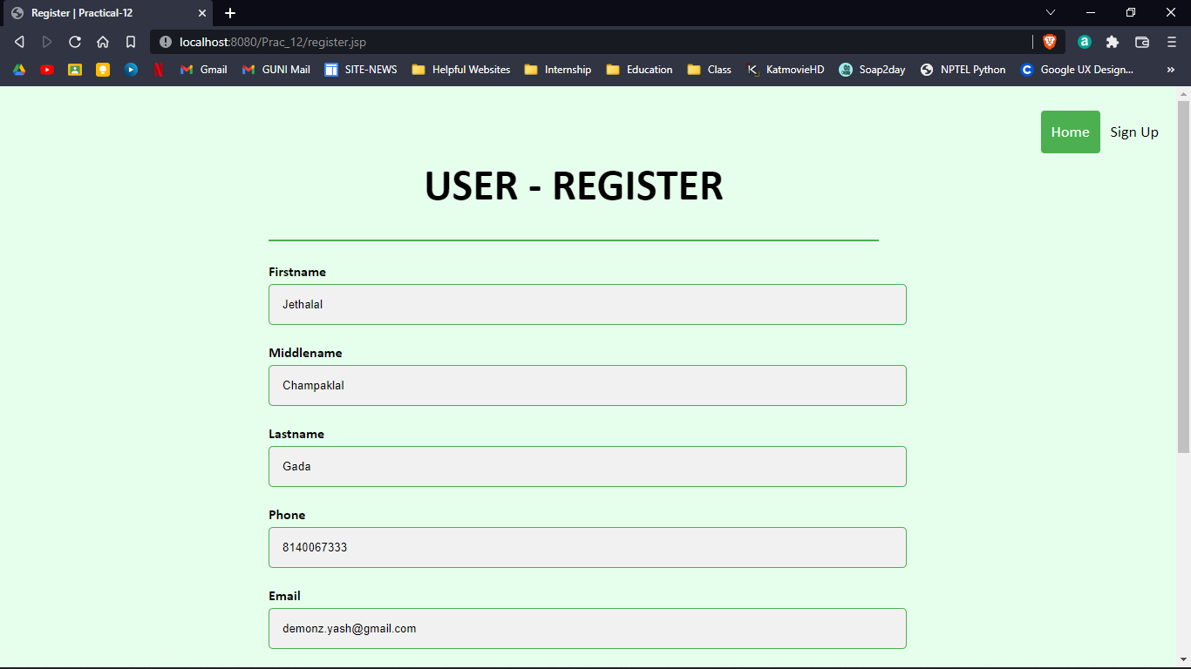

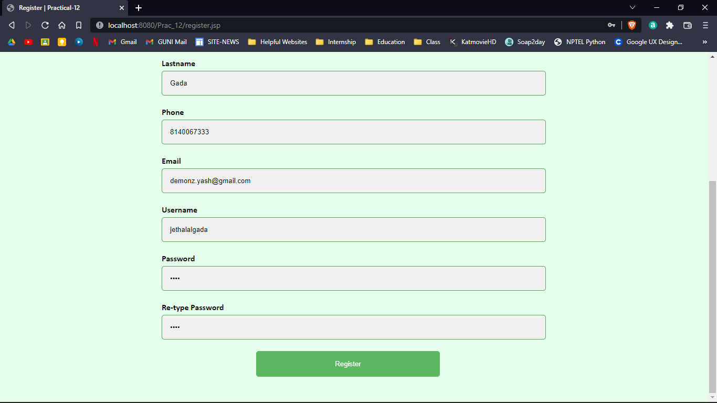

* If user doesn’t exists in database, it will redirect to “Bank Account Registration” module.

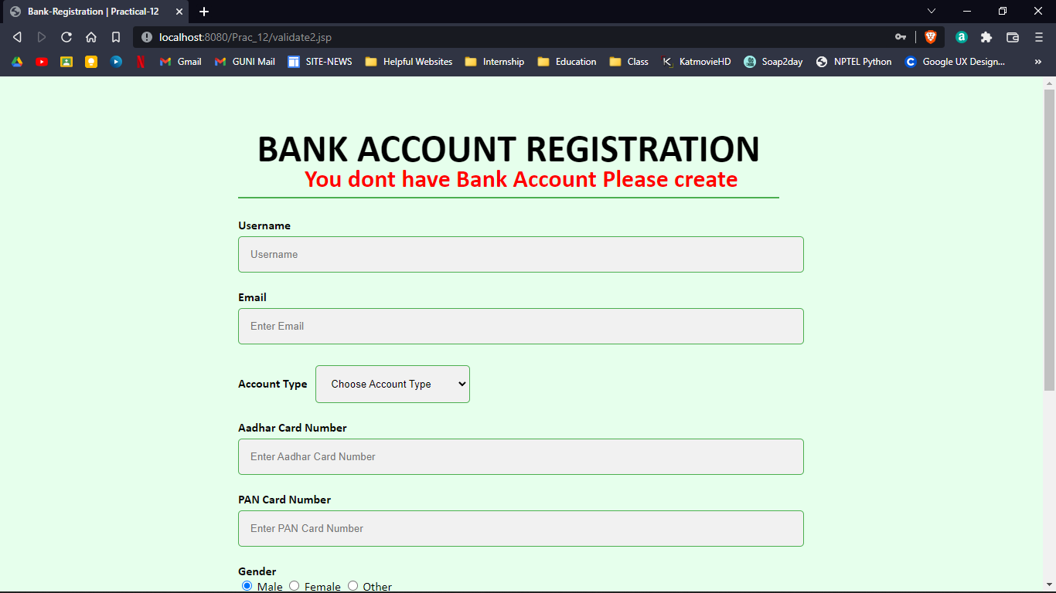

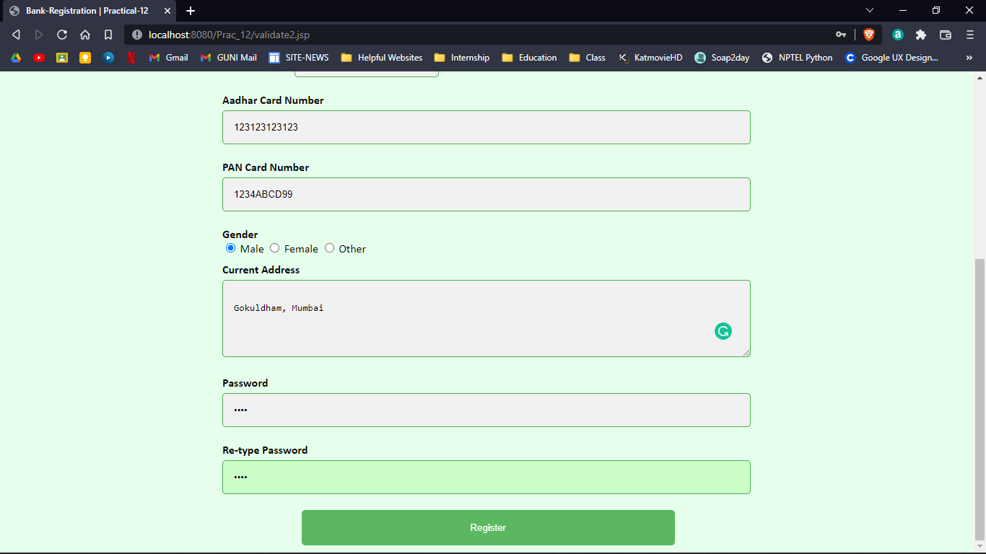

* This is the dashboard of user page

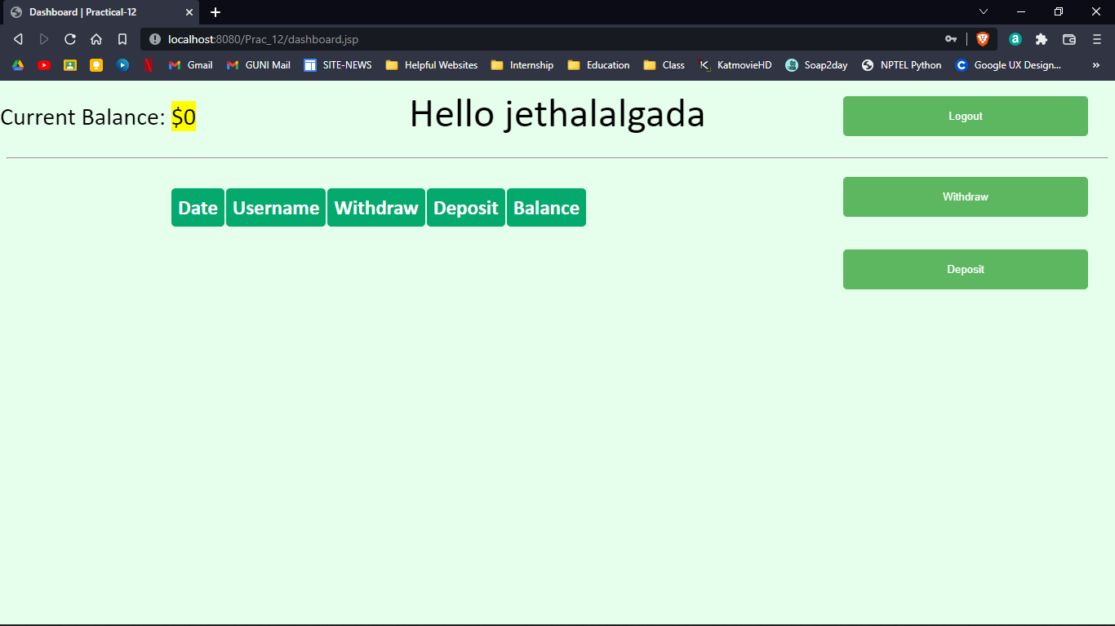

* This is “Deposit” module

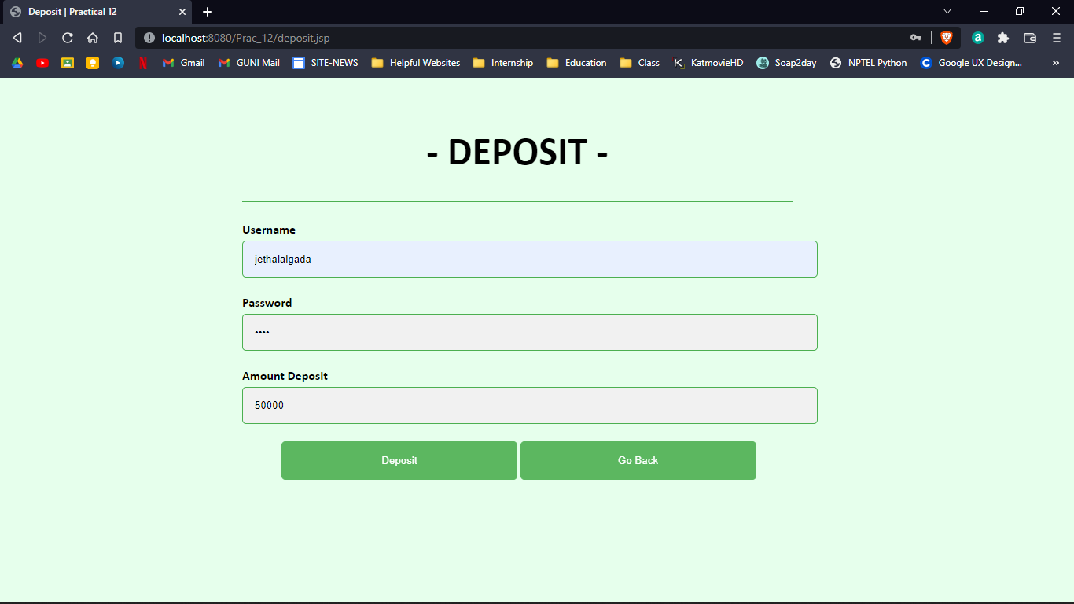

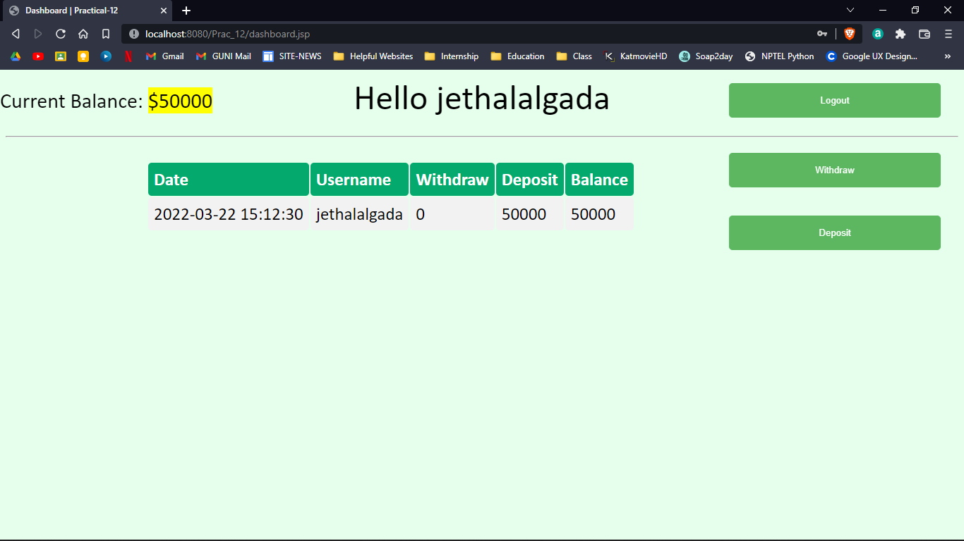

* This is “Withdraw” module

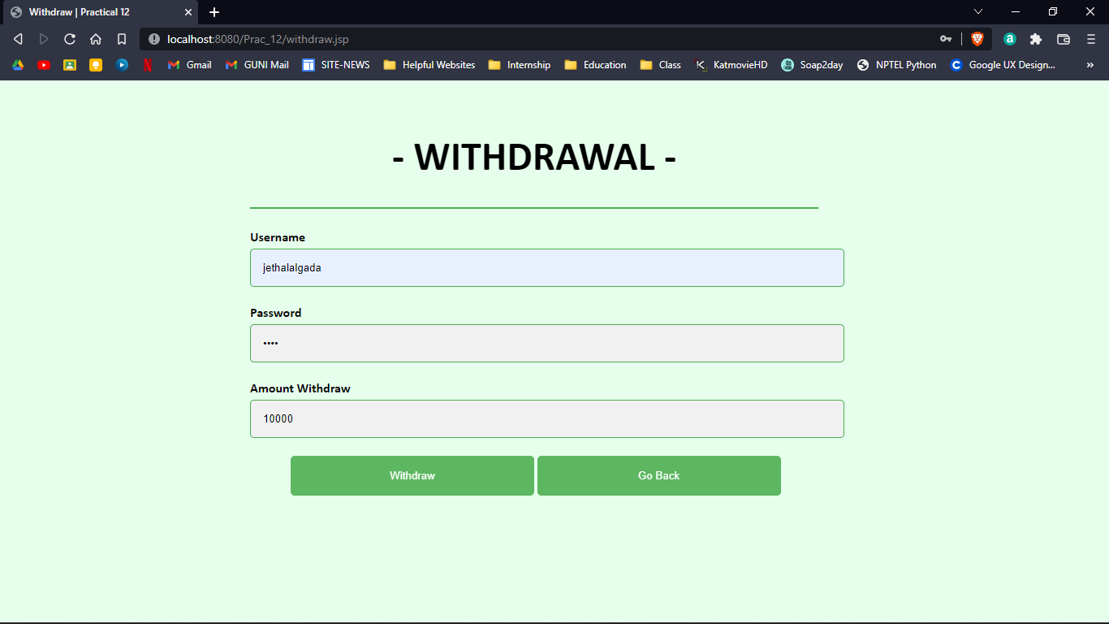

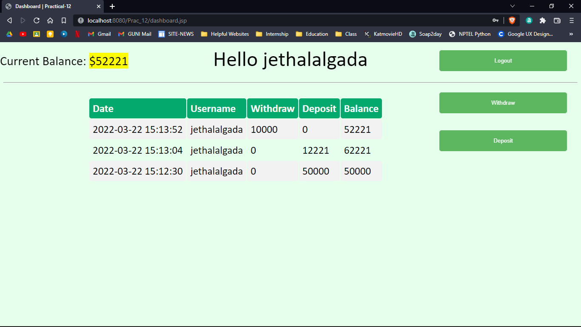

* Confirmation for logout of user

